Project Design Phase-II
Data Flow Diagram & User Stories

Date | 29 September 2026
Team ID | SWTID-2026-7933
Project Name | AI FAQ Assessment System
Maximum Marks | 4 Marks

DATA FLOW DIAGRAMS (DFD)
A Data Flow Diagram (DFD) visually represents the flow of information within the AI FAQ Assessment System. It depicts external entities, processing modules, natural language understanding pipelines, and data storage systems.
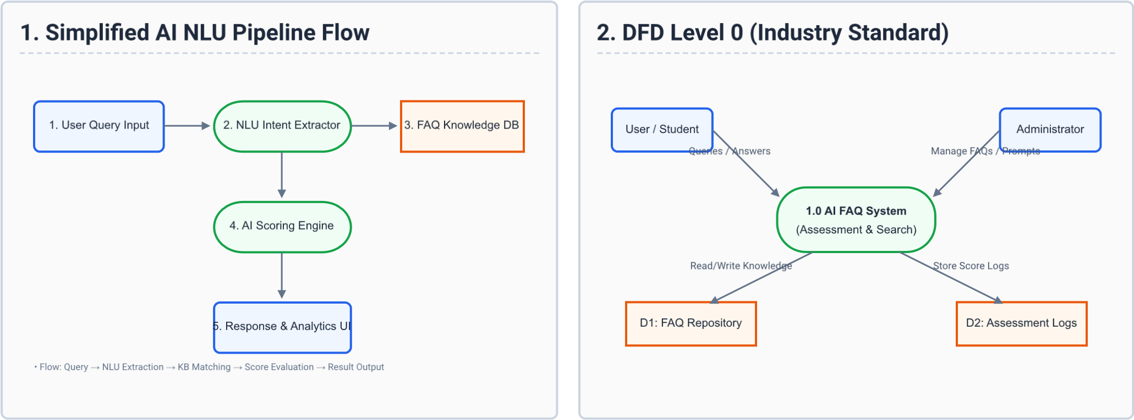

AI FAQ Assessment Project — SWTID-2026-6002 Page 1 of 2

USER STORIES & FUNCTIONAL REQUIREMENTS
The table below details all functional user stories across system roles: Customer (Mobile User), Customer (Web User), Customer Care Executive, and Administrator.
User Type | Epic / Module | ID | User Story / Task | Acceptance Criteria | Priority | Release
Customer  (Mobile User) | Authentication | USN-1 | As a mobile user, I can register using email and password. | Account created and login enabled. | High | Sprint-1
Customer  (Mobile User) | Authentication | USN-2 | As a mobile user, I can log in and view the AI FAQ search bar. | Dashboard loads with instant query input. | High | Sprint-1
Customer  (Mobile User) | FAQ  Assessment | USN-3 | As a mobile user, I can ask voice queries to get AI FAQ responses. | Voice recognized and accurate FAQ shown. | Med | Sprint-2
Customer  (Mobile User) | FAQ  Assessment | USN-4 | As a mobile user, I can rate the AI assessment accuracy (1-5 stars). | Rating saved to assessment database. | Low | Sprint-2
Customer (Web User) | Registration &  SSO | USN-5 | As a web user, I can sign up using Google / Social OAuth. | Single sign-on grants dashboard access. | High | Sprint-1
Customer (Web User) | FAQ Search & Test | USN-6 | As a web user, I can submit queries and receive semantic AI answers. | Relevant answer displayed with confidence score. | High | Sprint-1
Customer (Web User) | FAQ Search & Test | USN-7 | As a web user, I can view related automated follow-up questions. | 3 related FAQ chips shown below result. | Med | Sprint-2
Customer Care Exec | Query Review | USN-8 | As an executive, I can review low-confidence AI FAQ answers. | Flagged queries listed in review queue. | High | Sprint-1
Customer Care Exec | Query Review | USN-9 | As an executive, I can manually overwrite an incorrect AI answer. | Updated answer saved to training cache. | High | Sprint-2
Customer Care Exec | Feedback | USN10 | As an executive, I can forward unresolved queries to admins. | Escalation ticket generated automatically. | Med | Sprint-2
Administrator | Knowledge Base | USN11 | As an admin, I can upload CSV/PDF files to bulk import FAQs. | System parses and indexes new FAQs. | High | Sprint-1
Administrator | Model  Assessment | USN12 | As an admin, I can run automated precision/recall assessment metrics. | Accuracy score report generated. | High | Sprint-2
Administrator | User & Analytics | USN13 | As an admin, I can view usage analytics and system latency graphs. | Analytics dashboard displays metrics. | Med | Sprint-2

AI FAQ Assessment Project — SWTID-2026-6002 Page 2 of 2

